Training Fiche IHF

Title | Project Management for Telecommuters: Exploiting good practices from the DigComp Framework
Keywords (meta tag) | DigComp, digital skills, ICT literacy, telecommuting, smart working, resources
Provided by | IHF asbl
Language | ENG
Area | Digital and online communication | X
 | Team and people engagement from home
 | Work-life balance
 | Self-well being
 | “How to boost your team productivity from home?”
 | Remote project management
 | Agile Management by Objectives
 | “Smart” self-efficacy
 | Leadership and Motivation in the Smart Working era
 | Teleworking: a selection of digital tools to manage your business
Objectives / goals / learning outcomes
The objective of this training module is to introduce readers to the official EU framework for training and education on digital skills. Smart workers can leverage on the DigComp to identify training areas of greater interest for their upskilling on digital literacy and proficiency with IT tools.
Description
In 2013, the European Commission published the European Digital Competence Framework for Citizens (a.k.a. DigComp): a tool conceived as a teaching and training models to empower and strengthen EU citizens’ digital skills and proficiency with IT systems.

In the years following its publication, the framework gathered incredible success among Member States and it has been relied on as a very robust tool to design content and structure of national and cross national training programme with focus on many different operational settings (i.e., education and training, private sector and employment).
Contents arranged in 3 levels
Unit 1: Introducing the DigComp Framework
Section 1.1: Background, the DigComp 2.0
Section 1.2: DigComp 2.1
Section 1.3: About the 21 Competences – a visual representation
Section 1.4: DigComp 2.1 – training areas and competences

Unit 2: DigComp for telecommuters
Section 2.1: “Communication & Collaboration”
Section 2.2.: Exploiting the DigComp in your favour
Section 2.3: Interacting through digital technologies
Section 2.4: Sharing through digital technologies
Section 2.5: Collaborating through digital technologies
Section 2.6: Netiquette
Section 2.7: Managing digital identity
Section 2.8: How can you make further use of the DigComp?
Section 2.9: Best practices in the implementation of the DigComp 2.1

Unit 3: Further hints for remote PM
Section 3.1: General facts about remote project management
Section 3.2: Capitalising on benefits while containing negative impacts (1, 2)
Section 3.3: List of good-practices for remote project management

Contents in bullet points
- In 2013, the European Commission published the European Digital Competence Framework for Citizens (a.k.a. DigComp): a tool conceived as a teaching and training models to empower and strengthen EU citizens’ digital skills and proficiency with IT systems. In the years following its publication, the framework gathered incredible success among Member States and it has been relied on as a very robust tool to design content and structure of national and cross national training programme with focus on many different operational settings (i.e., education and training, private sector and employment).

- Since the beginning of the last decade, digital technologies evolved at exponential rates. In view of the new context, the European Commission promoted an updated revision of the DigComp that came in 2016 with the DigComp 2.0: a conceptual reference model of 21 competences divided among five strategic areas of training, and foreseen as the very “essential” of digital literacy. The scale and scope of DigComp 2.0 (and following revisions) are essentially three:
  - Support better informed policy interventions in the domain of digital citizenship
  - Support better informed training curricula at both formal and informal level
  - Support better informed evaluation models for the assessment of learning outcomes

- The 2016’s revision of DigComp was already anticipated by the 2.0 version. More in general, the DigComp 2.1 gives further continuity to a research area that is of JRC’s interest since 2005 and it is focused on:
  - Rethink learning through the exploitation of ICT
  - Innovating education curricula to address the new demand of digital competences in the labour market
  - Favour better equal opportunities for socio-economic inclusion and employability

- In the 2.1 version, each of the 21 competence is further classified based on a 8-level evaluation model that is conceived to identify with more precision learning outcomes and key skills that learners are expected to acquire to strengthen and foster their digital expertise.

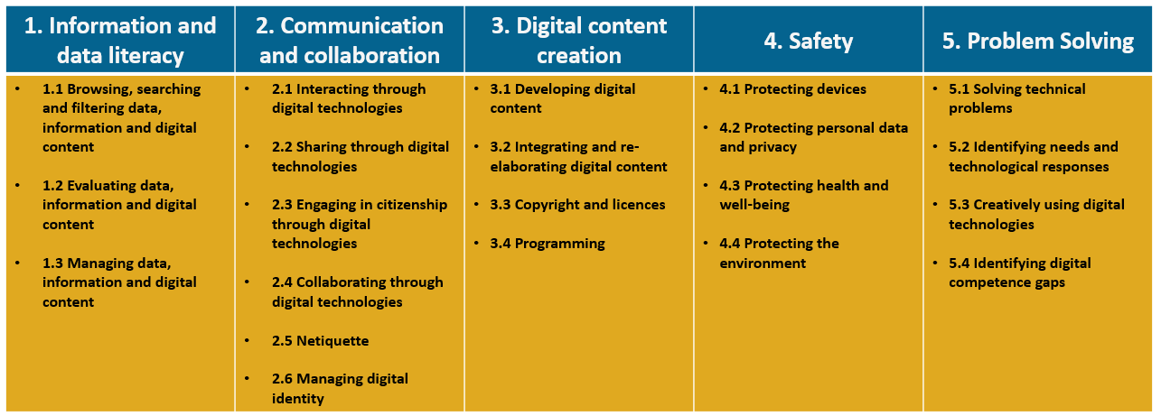

- Although all pillars detain extreme relevancy for telecommuters, Communication & Collaboration gains particular significance for those organisations/teams invested in large scale projects impacting and/or involving several external parties. Remote working prevents project managers from quick exchange of information with colleagues and staff members in general, reducing their efficacy (and effectiveness) in carrying out their activities. Moreover, meeting and coordinating with partners/clients from remote can generate misconceptions since the communication is limited to the verbal channel only.

- Considering the scale and scope of traditional project management activities, interacting, sharing and collaborating through digital technologies (respectively, competence no. 2.1, 2.2 and 2.4) are essential technical competences for in-remote project managers.

- On the other hand, netiquette and managing the digital identity (respectively, competence no. 2.5 and 2.6) become fundamental soft competences to validate in the eyes of an outsider one’s own values, reputation and reliability – as people would normally seek to do in person.

- As of today, the DigComp 2.1 remains one of the most (if not THE most) comprehensive framework for the assessment and evaluation of IT readiness and responsiveness of common citizens and well as public administrations and private organisations. The first thing you might trying do is self-assessing, by your own or with your project team, what is your current proficiency level with Collaboration & Cooperation competences for remote working and remote project management.

- The potential application of the DigComp 2.1 are very wide and diverse. As a matter of facts, in 2018 and 2020, the European Commission published two official follow-up intended to mainstream and showcase EU and cross-national best practices in the implementation of the DigComp in educational settings (DigComp Into Action) and private businesses (DigComp At Work). Out of the two, you will be particularly interested in the second, as it tackles numerous challenges that are typically addressed by private organisation at the edge of their digital transition.

- There is no doubt that remote project management comes with both benefits and disadvantages:

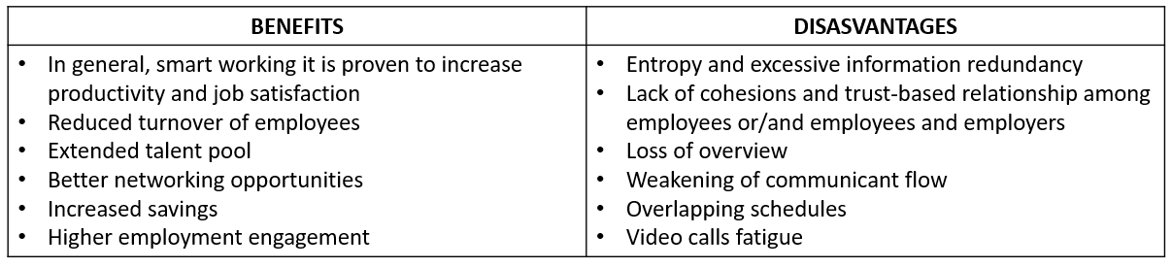

- There are several ways in which project managers can secure benefits and employees’ satisfaction from the negative outcomes that might come with remote working. In general, it has been observed that smart working produces positive impacts as long as:
  - Organisation are successful in fostering and maintaining a trust-based culture
  - Employers avoid micromanagement attitudes
  - Employees find better opportunities for work-life balance

- If only one out of the aforementioned conditions start missing, the organisation starts experiencing higher level of stress and unproductivity.

- List of good practices for remote project management:
  - Start by setting-up adequate remote project management tools that are intuitive, user-friendly and easy to access
  - Take a step-back and allow your team to manage their time. You will be fine as long as they manage to comply with internal deadlines
  - Be as precise as possible when assigning a tasks. Most of communication will happen via email/text, which by nature, leave more room for misinterpretations…
  - …Same for feedbacks and revision guidelines
  - Know your employees and redistribute roles and responsibilities
  - Establish specific communication channels – but do not overflow them of inputs
  - Make sure that communication is transparent and efficient. Set a commonly agreed calendar of “briefing” calls
  - Nurture a collaboration culture. Consider to set up new file storage systems that everyone can easily access to
  - Monitor key milestones’ achievements and inform your team in advance about any recommended adjustment
  - Check on your time, not only to seek about the status of their work…
  - Intercept any potential conflict that might emerge between two (or more) of your employees
  - Capitalise on your team’s internal diversity, leave room for self-initiative and brainstorm with your people on never-considered-before alternatives to common issues
5 glossary entries
- DigComp: the official framework from the EU Commission for EU citizens’ empowerment of digital skills and IT literacy
- DigComp into Action: a compendium of case studies selected by the EU Commission as “best practices” in the implementation of the DigComp 2.1 within education and training settings
- DigComp at Work: a compendium of case studies selected by the EU Commission as “best practices” in the implementation of DigComp 2.1 within professional and market labour settings
- DigComp’s proficiency model: the 8-layer proficiency framework is the (self)assessment model that DigComp’s users can rely on to measure their progresses on each of the DigComp’s competence
- Remote Project management: leveraging on ICT solutions to manage from remote people, tasks and processes
Bibliography and Further References
N/A
5 multiple-choice self-assessment questions
1) Which one of the following is not a DigComp’s training pillar?
- Digital Content creation
- Safety
- Digital Entrepreneurship

2) Which one of the following affirmation relating to “Communication and collaboration” is false
- Netiquette applies to both professional and social interactions
- Managing digital identity can be part of a personal branding strategy for professionals
- It first requires basics of programming and cybersecurity

3) The DigComp in professional settings is intended for the use of:
- Large scale corporations only
- Small and micro-organisations only, including third sector operators
- There are no limitations to its applications

4) When we look at the benefits of remote project management, we include:
- Extended talent pool
- Better cohesion among managers and employees
- More robust communication flow

5) As good practice for remote project management, we should consider:
- Micromanagement of employees, so to avoid lacks/lags in information exchange
- Leveraging on team’s diversity, in terms of competences, expertise and background
- Close monitoring of KPIs, specifically the time that employees spend of activities

Related Material | N/A
Related PPT | SWIFT IO3_IHF
Reference Link | DigComp 2.1: https://publications.jrc.ec.europa.eu/repository/handle/JRC106281  DigComp into Action: https://publications.jrc.ec.europa.eu/repository/handle/JRC110624  DigComp at Work: https://publications.jrc.ec.europa.eu/repository/handle/JRC120376
Video in YouTube format (if any) | N/A

