Training Fiche IDP

Title | The Entrepreneurial Competence Framework to thrive in post-COVID:  EntreComp for Smart Workers
Keywords (meta tag) | EntreComp, resilience, framework, education, training, telecommuting, smart working, resources
Provided by | IDP European Consultants
Language | ENG
Area | Digital and online communication
 | Team and people engagement from home
 | Work-life balance
 | Self-well being
 | “How to boost your team productivity from home?” | X
 | Remote project management
 | Agile Management by Objectives
 | “Smart” self-efficacy | X
 | Leadership and Motivation in the Smart Working era | X
 | Teleworking: a selection of digital tools to manage your business
Objectives / goals / learning outcomes
The objective of this training module is to help targets in familiarising with the EntreComp Framework – the official EU framework for training and education on entrepreneurial attitudes. As we described in the material, EntreComp’s pillars can decoded as strategic entry points to strengthen entrepreneurial resilience and adaptability to external shocks.

What entrepreneurs can take away from EntreComp is a reliable reference framework to measure and counter-evaluate their level of proficiency in transiting to a renewed mindset and operative model: from catchers-up to drivers of transformation and growth
Description
Throughout the years following its publication, the EntreComp became the favorite reference model for many transnational, EU-wide and national initiatives aimed at empowering and nurturing entrepreneurial spirits and sense of initiative among a very vast and diverse cohort of targets (i.e., entrepreneurship learners).

By design, the EntreComp framework is adaptable to many different settings that goes from secondary school and higher education, to corporate training, self-employability and professional career development.
Contents arranged in 3 levels
Unit 1: An Holistic approach to EntreComp
Section 1.1: The Entrepreneurial Competence Framework
Section 1.2: The EntreComp for entrepreneurial resilience
Section 1.3: Implementing the EntreComp: where to start
Section 1.4: Section 1.4: EntreComp Playbook

Unit 2: “Resources” for Smart Working
Section 2.1: “Resources” for Smart Working
Section 2.2: Motivation and perseverance
Section 2.3: Mobilizing resources
Section 2.4: Mobilizing Others
Contents in bullet points
- Back in 2016, the Joint Research Centre from the European Commission published the EntreComp Framework: a capacity assessment model designed to help professional in the domain of entrepreneurial coaching in identifying and better tackle key training areas for aspiring and established entrepreneurs. From another perspective, the EntreComp framework was also intended to generate common agreement among professionals and academics on the “essentials” of entrepreneurship as a multidimensional set of competence area.

- Throughout the years following its publication, the EntreComp became the favorite reference model for many transnational, EU-wide and national initiatives aimed at empowering and nurturing entrepreneurial spirits and sense of initiative among a very vast and diverse cohort of targets (i.e., entrepreneurship learners). By design, the EntreComp framework is adaptable to many different settings that goes from secondary school and higher education, to corporate training, self-employability and professional career development.

- The EntreComp Framework showcases 15 competences (referred to as the “building blocks” of entrepreneurship) grouped in groups of five under three competence areas of interest:

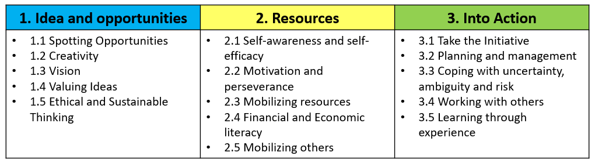

- EntreComp’s pillars can be also decoded as strategic entry points to strengthen entrepreneurial resilience and adaptability to external shocks. What entrepreneurs can takeaway from EntreComp is a reliable reference framework to measure and counter-evaluate their level of proficiency in transiting to a renewed mindset and operative model: from catchers-up to drivers of transformation and growth.

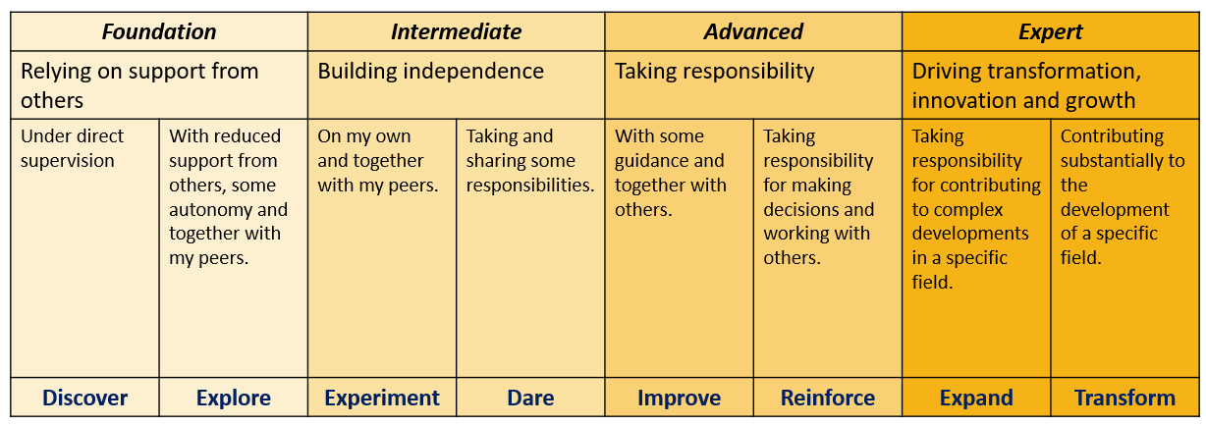

- Readers should look at the previous table as the road map of their transition towards remote work-friendly approaches to people and process management. The 8-dimension progress model is intended to set-up the formal key milestones under which any development programme might progress. By relying on the aforementioned table, entrepreneurs can keep track of how effective they are in helping their people in adapting to new working scenarios, discover opportunities within, and expand their intangible know how.

- Potentially, all 15 competences might be of strategic relevance to help entrepreneurs in sustaining their full embracement of smart working as a new competitive framework for entrepreneurial resilience and competitiveness:
- Ideas & Opportunities → as smart working is emerging as a new shaping models of business sustainability and long-term visions
- Resources → as smart working implies the re-engineering of many tangible and intangible business’ assets
- Into Action → as smart working triggers concrete impacts that should be dealt with in practice

- Luckily for readers, in 2018 and 2020 respectively, the Joint Research Centre of the European Commission published two very interesting reports listing a detailed series of case studies and best practices in the implementation of EntreComp at both dimensions: education and training, private sector and professional development

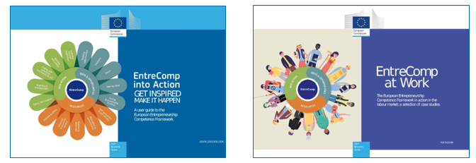

- Designed for the use of trainers and consultants operating beyond the formal education system, the EntreComp Playbook is conceived as an operative and practical manual to operationalise the EntreComp framework in professional settings with detailed guiding principles, methods, tools and techniques.

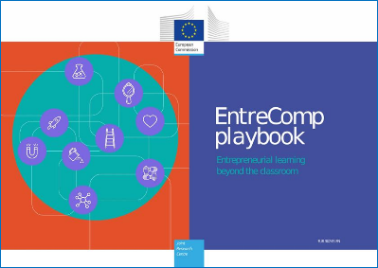

- In the previous section, we looked at the second pillar of EntreComp with particular interest. More specifically, there are three competences falling under this pillar that seems of strategic relevance for smart working embracement at organisation level:
2.2 Motivation and perseverance
2.3 Mobilising resources
2.5 Mobilising others

- MOTIVATION and PERSEVERANCE: Smart working can be tough: researches demonstrates that its benefits start showing up in the medium-run and takes some efforts to be nurtured, consolidated and valorised. Being inpatient is not of help: invest time in seeking information on how to best rely on smart working while taking into consideration the specific operational context of your organisation, skills and competences of your team, drivers of support, and external best practices (please, feel free to consult the EntreComp at Work as it is specifically tuned on private sector’s need-assessment and skills-gap).

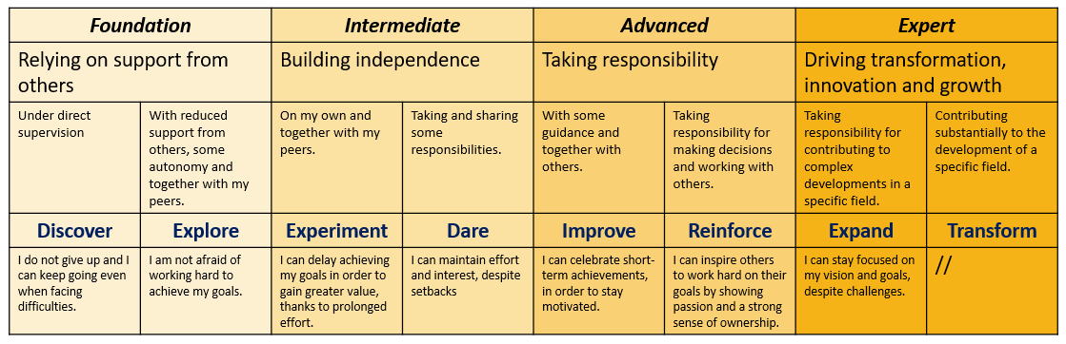

- MOBILISING RESOURCES: By resources, we imply specifically digital resources and IT systems that can boost your and your team productivity from remote. Smart working comes with a new way to interface with digital technologies and IT environments: a smooth digital transition is the sine qua non condition under which small enterprises remain competitive in global markets, keep on reach and engaging customers, strengthen their brand identity and public image.

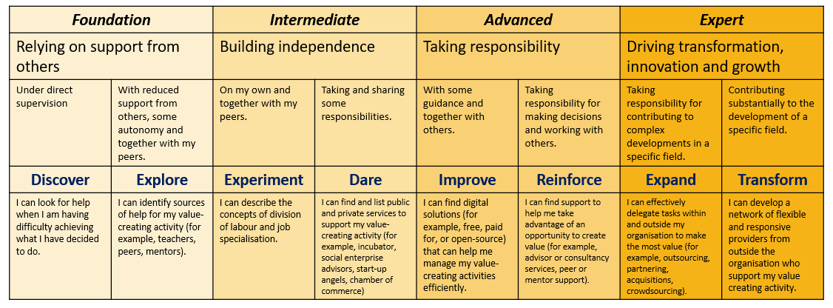

- MOBILISING OTHERS: At times, this happens to be the most difficult task: relating with technologies is much more intuitive and linear than relating with people. The sudden advent of smart working has put under stress-test many established business paradigms, one of which is represented by consolidated HR practices and STKH management that start appearing as fallacious in the new domains of practice. Smart working – and the full transitions of societies into the digital domain – disrupted previous relational models between organisation and people gravitating around it.

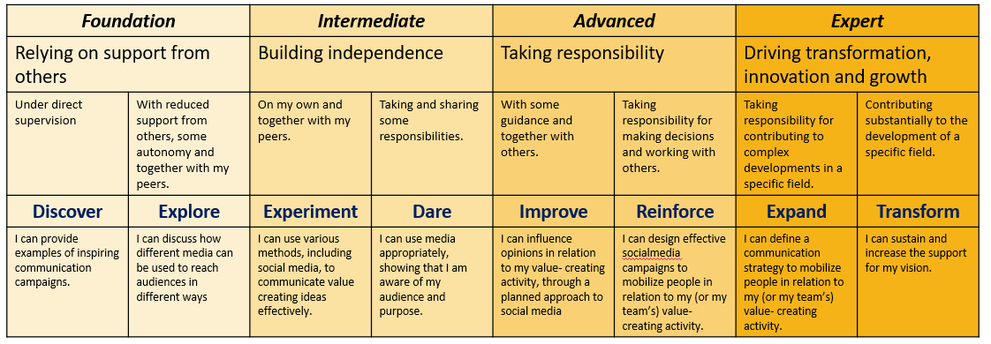

5 glossary entries
- EntreComp Framework: The official EU framework for training, education and capacity building on entrepreneurial competences and sense of initiative
- EntreComp Into Action: a compendium of case studies and best practices selected by the EU Commission in the implementation and valorization of the EntreComp in educational settings
- EntreComp at Work: a compendium of case studies and best practices selected by the EU Commission in the implementation and valorization of the EntreComp in professional settings for career guidance and development
- EntreComp Playbook: a compendium of tools and methodologies designed to operationalise the EntreComp framework in professional settings with detailed guiding principles, methods, tools and techniques
- EntreComp’s progression model: an 8-layer progression model that EntreComp’s users can rely on to (self)assess their progresses on each of the 15 competences
Bibliography and Further References
N/A
5 multiple-choice self-assessment questions
1) The EntreComp Framework is the official EU model for education and training on:
- Active citizenship
- Sense of initiative and entrepreneurial attitude
- Digital Entrepreneurship

2) The three EntreComp’s pillars are:
- Ideas & Opportunities, Resources, Into Action
- Resources, Financial Literacy, Intellectual Capital
- Into Theory, Into Action, Into Practice

3) Which of the following is not an EntreComp’s competence
- Learning through experience
- Working with others
- Cybersecurity

4) If one is interested in seeking for best practices in EntreComp’s implementation within professional settings, the resource to go is:
- EntreComp into Action
- EntreComp at Work
- EntreComp Playbook

5) Which one of the following pairs of competences is more relevant than other for telecommuters
- Mobilising resources and valuing ideas
- Mobilising resources and mobilising others
- Motivation & perseverance & creativity

Related Material | N/A
Related PPT | SWIFT IO3_IDP
Reference Link | EntreComp: https://ec.europa.eu/jrc/en/entrecomp  EntreComp Into Action https://publications.jrc.ec.europa.eu/repository/handle/JRC109128  EntreComp at Work: https://publications.jrc.ec.europa.eu/repository/handle/JRC120486  EntreComp Playbook: https://publications.jrc.ec.europa.eu/repository/handle/JRC120487
Video in YouTube format (if any) | N/A

